Combined Sewer Overflows (CSO)

Background
The City of Grafton operates and maintains a wastewater collection system. The collection system consists of more than 100 miles of gravity sewer pipe ranging in size from 4 inches to 24 inches. Access to the collection system is provided through more than 500 manholes.
Ten sewage lift stations pump sewage through more than 4 miles of force main to the gravity collection system. The collection system conveys the sewage to the Wastewater Treatment Plant located along the Tygart River.

Combined Sewer Overflows
The collection system of the City of Grafton is a combined sewer system.
Combined sewer systems carry both sanitary waste and stormwater drainage. Combined Sewer Overflows (CSOs) are outlet pipes that discharge excess water from the combined sewer system into streams and rivers during high flow conditions. Many older communities in the eastern United States have combined sewer systems.
Ironically, CSOs were first devised as a means to improve public health and safety by keeping sewers from backing up into homes, businesses and streets during heavy rain events. Today CSOs from combined sewer systems are considered pollution sources and CSO communities are required by the Clean Water Act to develop plans to reduce CSO discharge
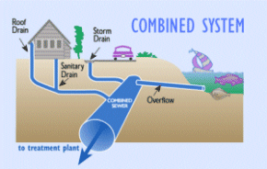
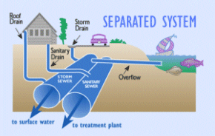
Combined sewer systems are no longer constructed. Today, separate systems are constructed for sanitary sewage and for stormwater.

Why We Have CSOs
Prior to 1972, when the City of Grafton Wastewater Treatment was put in service, the combined sewer system discharged at various points along local rivers and streams. Along with the new wastewater treatment plant, "interceptor pipes" were installed along the waterways and the combined sewer system discharge pipes were connected to these interceptor pipes. Pumping stations were also installed to deliver the sewage to the treatment plant.
At various locations, CSOs were installed to discharge excess flow from rain events that could possibly flood the pumping stations, or exceed the treatment plant capacity.

Monitoring of CSOs
The City of Grafton inspects its 13 CSOs at least once a week for dry weather overflows. Each CSO is also inspected after major rainfall events.
If a dry weather overflow is detected, regulatory agencies are notified and corrective measures are undertaken as soon as possible. Typical causes of dry weather overflows are sewer line blockages and mechanical problems at pumping stations.
Inspection reports are prepared for all inspections and kept in a logbook. A copy of this logbook is maintained at the information counter on at City Hall at 1 West Main Street, for public review.

The City of Grafton Program
The City of Fairmont continues to implement the Nine Minimum Controls as outlined by the United States Environmental Protection Agency. The nine minimum controls are:
- Control of Solids and Floatable Materials
- Elimination of Dry Weather Overflows
- Maximization of Flow to the Wastewater Treatment Plant
- Maximization of Storage in the Collection System
- Monitoring to Characterize CSO Impacts
- Pollution Prevention
- Proper Operation and Maintenance Program
- Public Notification
- Review and Modification of Pretreatment Requirements
The Nine Minimum Controls are considered a set of good housekeeping practices aimed at minimizing the frequency of CSO discharges at a minimal cost.

Public Notice of CSOs
Warning signs have been placed at and around CSO outfall locations. The signs indicate that a CSO overflow is nearby and the waters may be polluted during and immediately following rain events. The CSOs should only discharge during wet weather.

